Forum: The Third General Assembly
Issue: Measures to suppress the drug overdose crisis located in Scotland
Student officer: Rayyan Alkiswani
Position: Chair of GA3

- Introduction

Drug overdose is a major cause of death and illness among illicit drug users. Over the past couple of years this has become a gargantuan problem around the world as drug-related deaths have risen exponentially. Around 450,000 people have died from an overdose involving any opioid from 1999 to 2018. This number including people with prescription opioids.

In some countries around the world, their leading cause of death for citizens under 50 years old is death to an accidental drug overdose. So number of death caused by drug overdoses in these countries now exceed those attributable to deaths caused by homicides, car accidents, HIV/AIDS, or firearms. Even the number of casualties in the entire Vietnam war is less than the deaths caused by drug overdoses in 2017 alone in some countries.

This issue has become a public health crisis with devastating consequences as studies have shown that roughly 21 to 29 percent of the patients with prescribed opioids for chronic pain end up misusing them. Moreover, other studies have proven that around 80 percent of people who currently use heroin, have first misused prescription opioids.

However, from all the countries in the world that suffer from a problem with drug overdose, Scotland in specific are having a massive problem with opioid overdose, being the most effected in the entire continent of Europe. In Scotland, almost 60,000 people suffer with a drug problem. This number is the highest proportion of the population (suffering from drugs) than any other European country. Scotland also have the highest fatal drug overdose rate than any other country in Europe per head of population.

- Definition of key terms

Opioids;
Natural, semisynthetic, or synthetic substance that resembles the addictive properties of opium and produces similar narcotic effects (euphoria, pain relief, sedation, and slow breathing).

Misuse;
Use (something) for a wrong purpose or in a wrong way.

Drug Deaths Task Force;
Governmental organization established in July 2019 by the Minister for Public Health and Sport, with a main goal to tackle the rising number of drug deaths in Scotland.

Addiction;
The compulsive psychological need for and usage of a habit-forming substance (such as heroin or nicotine).

Habit-forming substance;
Substance that tends to cause or encourage addiction, especially through physiological dependence.

- General Overview – Background information

General information on drug-related deaths in Scotland

In Scotland, almost 60,000 people suffer with a drug problem. This number is the highest proportion of the population (suffering from drugs) than any other European country. Scotland also have the highest fatal drug overdose rate than any other country in Europe per head of population.
Over the year of 2017, 934 drug overdose-related deaths were registered. This number shows that there were 66 more drug related deaths took place over 2017 than in 2016, this is an 8% increase in the number of casualties. From these 934 deaths in 2017, males accounted for 70% of the deaths. The majority of the drug-related deaths that year fall between the ages of 34-44 years old, accounting for 360 deaths from the 934, being responsible for 39% of the deaths. Responsible for 29% of the deaths are people between 45-54 years old, accounting for 268 of the 934. Finally, accounting for the remaining 185 deaths are people between the ages of 25 and 34 years old. Moreover, in 815 of the deaths, opioids such as heroin, morphine and methadone were implicated. Also benzodiazepines such as diazepam and etizolam were implicated or potentially contributed to 552 of the drug-related deaths in 2017.
With a high number of drug-related deaths already taking place in 2017, the numbers still rose in 2018 showing that the problem is getting worse as there was a 27% increase of drug related deaths for 2018 from 2017. Statistics showed that 1187 people died of drug misuse in 2018 in Scotland.

The role of poverty in Scotland’s drug overdose crisis
Netherlands and Sweden share the fact between each other that they both share a low level of problematic drug use although they both have different policies and approaches toward drugs. This shows that method by which drugs are approached by countries doesn’t really matter as these two countries might not share similar policies but both have low levels of drug problems.
However, another trait that both these countries share is that they both have lower rates of poverty than Scotland. The low levels of drug overdose is a result of the social policy of successive governments in these countries such as the Netherlands and Sweden as opportunity is spread more evenly across their societies. So it is wider government policy that has the greatest bearing on the scale of a country’s drug problem. Therefore, a great reason to the drug problem in Scotland has to do with how the Scottish government is dealing with the poverty levels.
Netherlands and Sweden share the fact between each other that they both share a low level of problematic drug use although they both have different policies and approaches toward drugs. This shows that method by which drugs are approached by countries does not really matter as these two countries might not share similar policies, but both have low levels of drug problems.
However, another trait that both these countries share is that they both have lower rates of poverty than Scotland. The low levels of drug overdose are a result of the social policy of successive governments in these countries such as the Netherlands and Sweden as opportunity is spread more evenly across their societies. So, it is wider government policy that has the greatest bearing on the scale of a country’s drug problem. Therefore, a great reason to the drug problem in Scotland has to do with how the Scottish government is dealing with the poverty levels.

Scotland’s drug issue compared to other countries in Europe
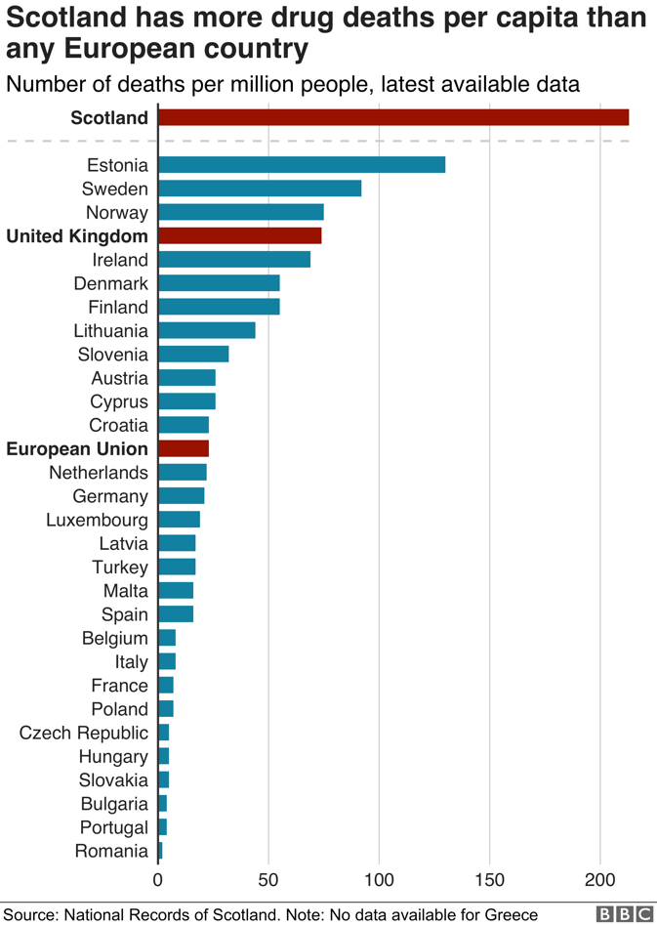
The 2018 figures showed that Scotland’s drug-related death rate was higher than all of the other European countries. With a drug-related death rate of 218 per million of the population, Scotland is by far leading Europe showing how intense the situation really is in Scotland. This number is about 4 times that of Wales and England, which have a rate of 51 per million.
The latest estimates are that Scotland has about 60,000 problem drug users, or 1.6% of the adult population.
Scotland has "proportionately way more drug users than the rest of the UK" says Dr Andrew McAuley, a senior research fellow at Glasgow Caledonian University. "That ultimately has an obvious impact on the number of drug-related deaths."
2018 figures showed that Scotland’s drug-related death rate was higher than all the other European countries. With a drug-related death rate of 218 per million of the population, Scotland is by far leading Europe showing how intense the situation really is in Scotland. This number is about 4 times that of Wales and England, which have a rate of 51 per million.
The latest estimates are that Scotland has about 60,000 problem drug users, or 1.6% of the adult population.
Scotland has "proportionately way more drug users than the rest of the UK" says Dr Andrew McAuley, a senior research fellow at Glasgow Caledonian University. "That ultimately has an obvious impact on the number of drug-related deaths."
2018 figures showed that Scotland’s drug-related death rate was higher than all the other European countries. With a drug-related death rate of 218 per million of the population, Scotland is by far leading Europe showing how intense the situation really is in Scotland. This number is about 4 times that of Wales and England, which have a rate of 51 per million.
The latest estimates are that Scotland has about 60,000 problem drug users, or 1.6% of the adult population.
Picture includes a bar graph containing numbers on the drug deaths per capita for different countries in Europe, showing that Scotland has the most out of any other country in Europe.
Scotland has "proportionately way more drug users than the rest of the UK" says Dr Andrew McAuley, a senior research fellow at Glasgow Caledonian University. "That ultimately has an obvious impact on the number of drug-related deaths."
Netherlands and Sweden share the fact between each other that they both share a low level of problematic drug use although they both have different policies and approaches toward drugs. This shows that method by which drugs are approached by countries does not really matter as these two countries might not share similar policies, but both have low levels of drug problems.
However, another trait that both these countries share is that they both have lower rates of poverty than Scotland. The low levels of drug overdose are a result of the social policy of successive governments in these countries such as the Netherlands and Sweden as opportunity is spread more evenly across their societies. So, it is wider government policy that has the greatest bearing on the scale of a country’s drug problem. Therefore, a great reason to the drug problem in Scotland has to do with how the Scottish government is dealing with the poverty levels.

The most used drugs
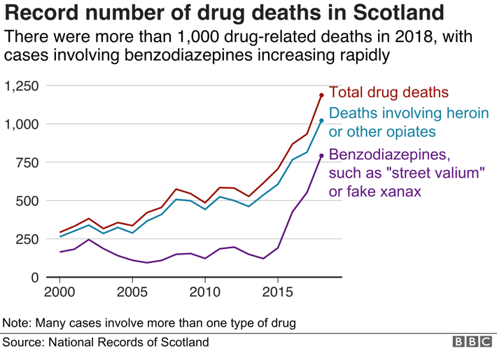
Most drug-related deaths in Scotland are of people who took more than one substance, so-called poly-drug use.
Picture includes a line graph containing the numbers of deaths based on each drug with different lines representing different drugs. Note that most deaths include more than one type of drug.
Opiates such as heroin and methadone are implicated in the vast majority of deaths but users are often taking a lethal cocktail of drugs which increasingly includes benzodiazepines such as etizolam - pills which are often dealt as "street valium" or "street blues".
Etizolam contributed to 548 deaths in 2018, more than three-quarters of all "street benzodiazepine" deaths.
Experts say that high-risk opioid users typically misuse benzodiazepines to self-medicate or increase the effects of heroin or methadone. They also take benzos to treat symptoms of psychiatric disorders, negative emotional states and withdrawal symptoms.

Where it’s happening
Problematic drug use is highest in areas of deprivation, where people are not getting opportunities in education and employment, according to Elinor Dickie of Public Health Scotland.
Drug use is 17 times higher in Scotland's poorest areas compared to the wealthiest.
Dundee City Council area has the worst rate in Scotland at 0.31 per 1,000 of the population, closely followed by Glasgow (0.30), and Inverclyde (0.25), which includes the towns of Greenock and Port Glasgow.
Edinburgh's rate (0.16) is the same as the average for the whole of Scotland but is still much higher than the UK average.
The three local authorities with the lowest rates of drug-related deaths in mainland Scotland are Aberdeenshire, as well as East Dunbartonshire and East Renfrewshire which border Glasgow but contain the well-off suburbs of Bearsden, Milngavie, Newton Mearns and Giffnock.
Rural areas such as Dumfries and Galloway, Highland and the Scottish Borders have pockets of problem drug users but their overall rate is much lower than the cities.

- Major parties involved and their views

Scottish government:
Since Scotland is the country being affected by a drug/opioid epidemic, of course the country let its government step in to try and help out the situation in the country. So far the Scottish government is trying in many different ways to help suppress the drug overdose epidemic in their country. However, the major action they took to help solve the issue was in the summer of 2019 where the Minister of Public Health and Sport established the Drugs Deaths Taskforce. Where the primary role of this taskforce is to co-operate and drive action to improve the health outcomes for people who use drugs, reducing the risk of harm and death.

- Timeline of Events
Date | Event
2016 | The Scottish Drugs Forum, with support from the Scottish Government, published Staying Alive in Scotland. This report was produced from engagement with Alcohol and Drug Partnerships. It identified Good Practice Indicators.
2017  218 per million of the population, Scotland is by far leading Europe showing how intense the situation really is in Scotland. This number is about 4 times that of Wales and England, which have a rate of 51 per million.  The latest estimates are that Scotland has about 60,000 problem drug users, or 1.6% of the adult population.  Scotland has "proportionately way more drug users than the rest of the UK" says Dr Andrew McAuley, a senior research fellow at Glasgow Caledonian University. "That ultimately has an obvious impact on the number of drug-related deaths."  2018 figures showed that Scotland’s drug-related death rate was higher than all the other European countries. With a drug-related death rate of 218 per million of the population, Scotland is by far leading Europe showing how intense the situation really is in Scotland. This number is about 4 times that of Wales and England, which have a rate of 51 per million.  218 per million of the population, Scotland is by far leading Europe showing how intense the situation really is in Scotland. This number is about 4 times that of Wales and England, which have a rate of 51 per million.  The latest estimates are that Scotland has about 60,000 problem drug users, or 1.6% of the adult population.  Scotland has "proportionately way more drug users than the rest of the UK" says Dr Andrew McAuley, a senior research fellow at Glasgow Caledonian University. "That ultimately has an obvious impact on the number of drug-related deaths."  2018 figures showed that Scotland’s drug-related death rate was higher than all the other European countries. With a drug-related death rate of 218 per million of the population, Scotland is by far leading Europe showing how intense the situation really is in Scotland. This number is about 4 times that of Wales and England, which have a rate of 51 per million.  218 per million of the population, Scotland is by far leading Europe showing how intense the situation really is in Scotland. This number is about 4 times that of Wales and England, which have a rate of 51 per million.  The latest estimates are that Scotland has about 60,000 problem drug users, or 1.6% of the adult population.  Scotland has "proportionately way more drug users than the rest of the UK" says Dr Andrew McAuley, a senior research fellow at Glasgow Caledonian University. "That ultimately has an obvious impact on the number of drug-related deaths."  2018 figures showed that Scotland’s drug-related death rate was higher than all the other European countries. With a drug-related death rate of 218 per million of the population, Scotland is by far leading Europe showing how intense the situation really is in Scotland. This number is about 4 times that of Wales and England, which have a rate of 51 per million.  218 per million of the population, Scotland is by far leading Europe showing how intense the situation really is in Scotland. This number is about 4 times that of Wales and England, which have a rate of 51 per million.  The latest estimates are that Scotland has about 60,000 problem drug users, or 1.6% of the adult population.  Scotland has "proportionately way more drug users than the rest of the UK" says Dr Andrew McAuley, a senior research fellow at Glasgow Caledonian University. "That ultimately has an obvious impact on the number of drug-related deaths."  2018 figures showed that Scotland’s drug-related death rate was higher than all the other European countries. With a drug-related death rate of 218 per million of the population, Scotland is by far leading Europe showing how intense the situation really is in Scotland. This number is about 4 times that of Wales and England, which have a rate of 51 per million. | Over the year of 2017, 934 drug overdose-related deaths were registered. This number shows that there were 66 more drug related deaths took place over 2017 than in 2016, this is an 8% increase in the number of casualties. From these 934 deaths in 2017, males accounted for 70% of the deaths. The majority of the drug-related deaths that year fall between the ages of 34-44 years old, accounting for 360 deaths from the 934, being responsible for 39% of the deaths. Responsible for 29% of the deaths are people between 45-54 years old, accounting for 268 of the 934. Finally, accounting for the remaining 185 deaths are people between the ages of 25 and 34 years old. Moreover, in 815 of the deaths, opioids such as heroin, morphine and methadone were implicated. Also benzodiazepines such as diazepam and etizolam were implicated or potentially contributed to 552 of the drug-related deaths in 2017.
2017 | The most recent evidence review carried out in Scotland into drug-related deaths was carried out by NHS Health Scotland (Dickie et al 2017). Keeping people safe was published in 2017 and remains relevant. This rapid evidence review raised the key points that there is review-level evidence that the health of individuals with opioid dependence is safeguarded while in substitution treatment, It is important to consider which medications work for whom, the first 4 weeks of treatment and the first 4 weeks after leaving treatment are critical intervention points to reduce mortality risk, one size does not fit all. Treatment approaches and services need to be tailored to the individual to support them to stay in treatment, psychosocial interventions in conjunction with medication-assisted treatment have been shown to contribute to improving outcomes for people with opioid dependence, complex psychological and social barriers must be addressed to support individuals to access services, a holistic approach, designed and tailored to the health and social needs of individuals, will improve the effectiveness of interventions, help increase motivation and prevent drop out. Treatment and harm-reduction services are effective in reducing the transmission of blood-borne viruses. And take-home naloxone programs have been demonstrated to increase the odds of recovery from overdose and improve knowledge of overdose recognition and management in the community.
2018 | With a high number of drug-related deaths already taking place in 2017, the numbers still rose in 2018 showing that the problem is getting worse as there was a 27% increase of drug related deaths for 2018 from 2017. Statistics showed that 1187 people died of drug misuse in 2018 in Scotland.
2019 | The indicators from the Staying Alive in Scotland report released in 2016 were refreshed in a new edition of Staying Alive, published in November 2019, to provide a self-assessment tool for ADPs to develop strategies to tackle the growth in drug deaths. Staying Alive 2019 sets out fourteen topic areas which ADPs should consider as forming part of their on-going local strategies such as drug-Related Death Monitoring and Learning, access to Services, opioid Substitution Therapy and Low Threshold Prescribing, Retention in Services, Continuity of Care, Trauma and Assertive Outreach, Information Sharing, High Risk Injecting, Wound Care and Bacterial Infections, Blood Borne Virus Testing and Treatment, Naloxone, Prison Throughcare and Police Custody, People Aged 35 and Over Who Use Drugs, Dual Diagnosis and Suicide, Homelessness, Housing and Rough Sleeping, Women Who Use Drugs, Poly-drug Use and Prescribed Medications.
July, 2019 | In the summer of 2019 where the Minister of Public Health and Sport established the Drugs Deaths Taskforce. Where the primary role of this taskforce is to co-operate and drive action to improve the health outcomes for people who use drugs, reducing the risk of harm and death.

- Evaluation of Previous Attempts to Resolve the Issue

In the summer of 2019 where the Minister of Public Health and Sport established the Drugs Deaths Taskforce. Where the primary role of this taskforce is to co-operate and drive action to improve the health outcomes for people who use drugs, reducing the risk of harm and death. The taskforce specifically examine and publish evidence of the triggers of drug deaths and what is learned about how they can be prevented.
They also work with partners to identify, spread and sustain good practice in Scotland.
They collate and publish good practice about what has worked in other parts of the UK and internationally to prevent death and harm arising from drug use.
The taskforce also identify specific barriers in the planning, commissioning and delivery of addiction services in Scotland.
They also review whether the Misuse of Drugs Act 1971 affects the provision of a strengthened and consistent public health approach to drug use, recognizing that this is reserved to the UK Parliament and any changes will require the agreement of the UK Parliament.
Moreover, they also make recommendations for changes in current health and social care practice and on how a public health approach to drugs might be more fully realized across all relevant services and in the justice system.
Additionally, they identify the full range of support services which help to reduce harm and identify deficiencies in the delivery framework, availability and provision of such services.
Finally, the taskforce identify the extent to which the availability of appropriate programs and treatment options limit the use of diversion from the criminal justice system or the use of constructive sentencing options within the criminal justice system.
This solution put forward by the Minister for Public Health and Sport, if implemented correctly, will be very efficient as this taskforce helps to suppress this problem from different sides and in different ways that are very helpful. The only worry about this solution is that the Scottish government hasn’t come up with any other big solution to back this up so if this solution ends up being a waste of time, then the problem will keep on becoming worse and worse but action needs to be taken immediately. Overall, I believe that by creating this taskforce, it will help suppress this opioid epidemic in Scotland.

- Possible solutions

The three international drug control conventions outline measures to limit illicit opioid availability while ensuring availability for medical and scientific purposes, in particular for addiction treatment, acute pain, cancer pain and palliative care, for which WHO recommends the use of opioids (pain ladder). Measures to limit the contribution of prescription medicines to opioid overdose include addressing the inappropriate prescription of opioids and other sedatives and inappropriate sales by pharmacies without a prescription. Effective drug prevention programs indirectly reduce overdose risk through reduction in drug use.
Commit the Government, Local Authorities and Police Scotland to work with third sector organizations and the relevant private sector agencies in all fields of work to ensure the provision of on-site testing for all Scottish people.

- Guiding questions
- (Country name)’s relation with Scotland?
- In what ways can poverty cause a drug epidemic in a country?
- How did the Scottish opioid crisis happen?
- Who are the Drug Deaths Task Force? What do they do?
- Is (country name) effected by drug-related deaths?
- What has (country name) done to help fight drugs?
- What areas have the highest overdose rates in Scotland? Why?
- What ages are accounting for the most drug-related deaths in Scotland?
- Are the addicted being treated?
- What reports have been published about the Scottish drug crisis?

- Appendices and useful links
- http://www.sdf.org.uk/blog-poverty-is-the-root-of-scotlands-fatal-drug-overdose-crisis/#:~:text=Scotland%20has%20almost%2060%2C000%20people,Europe%20per%20head%20of%20population.

- https://www.drugabuse.gov/drug-topics/opioids/opioid-overdose-crisis

- https://www.gov.scot/groups/drug-deaths-task-force/

- http://www.sdf.org.uk/news_scotlands_drug_strategy_refresh/

- http://www.sdf.org.uk/934-deaths-from-a-drug-overdose-in-scotland-in-2017/

- https://www.bbc.com/news/uk-scotland-48853004

- https://www.gov.scot/publications/drug-deaths-taskforce-emergency-response-january-2020/

- http://www.healthscotland.scot/media/1609/drugs-related-deaths-rapid-evidence-review.pdf

- https://www.drugpolicy.org/issues/drug-overdose

- https://www.unodc.org/docs/treatment/overdose.pdf

- http://www.sdf.org.uk/wp-content/uploads/2018/11/A-Drugs-Strategy-for-Scotland-SDF-response-to-the-Scottish-Government-proposal-to-refresh-Scotlands-existing-strategy.pdf

- Contact info

Email – rayyan_alkiswani@abs.edu.jo

