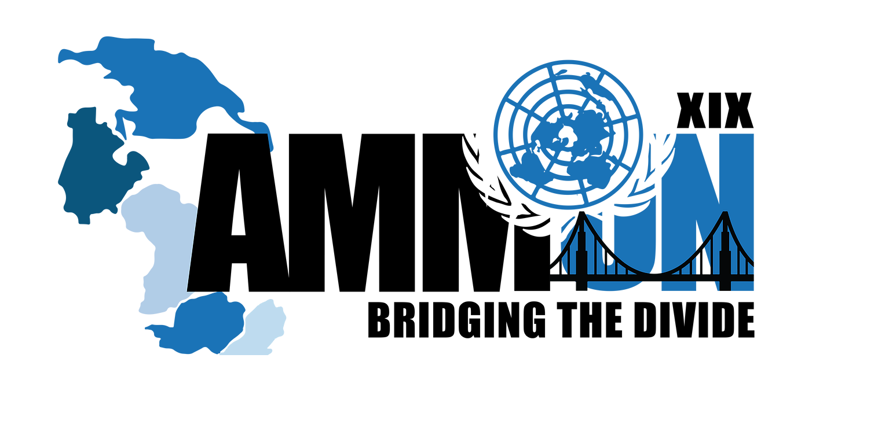

Forum: Advisory Panel
Issue: The Crisis in Afghanistan (Social)
Student Officer: Ahmad Asfour
Position: President of the Advisory Panel

- Introduction

Afghanistan, a landlocked country in southwestern Asia, bounded on the north by Turkmenistan, Uzbekistan, and Tajikistan; on the east by China and the part of the disputed territory of Jammu and Kashmir controlled by Pakistan; on the south by Pakistan; and on the west by Iran. Afghanistan was a monarchy from 1747 to 1973, when the king was overthrown by military officers and the country was proclaimed a republic; the republic dissolved in 1992 as the country erupted in civil war. Afghanistan lies across ancient trade and invasion routes from central Asia into India. This position has been the greatest influence on its history because the invaders often settled there.

Today the population includes many different ethnic groups. Most of the present borders of the country were drawn up in the 19th century, when Afghanistan became a buffer state, or neutral zone, between Russia and British India. Kabul is the capital and largest city. The executive branch of the Afghan National Unity Government consists of a powerful and popularly elected President, two Vice Presidents and a Chief Executive Office. A National Assembly consisting of two Houses, the House of People (Wolesi Jirga) with 249 seats, and the House of Elders (Meshrano Jirga) wiyh 102 seats forms the Legislative Branch. There is an independent Judiciary branch consisting of the Supreme Court (Stera Mahkama), High Courts and Appeal Courts. The President appoints the nine members of the Supreme Court with the approval of the Wolesi Jirga. President Hamid Karzai became the first democratically elected President of Afghanistan on December 7, 2004. Previously, Hamid Karzai had been Chairman of the Transitional Administration and Interim President from 2002.

- Definitions of Key Terms

- Civil War: A war between two or more parties in the same country.
- Buffer State: A country that acts as a neutral state between two hostile or rival countries.
- National Assembly: An elected legislature in a country.
- interethnic strife: Disagreement between Ethnic groups.
- Malnutrition: A condition due to the lack of proper nutrition,

- General Overview – Background information

Where 40 years of war has totally crippled the economy, and you must try to somehow survive day-by-day by scrounging enough food to feed your children. Where people do not have the facilities to receive an education. Where people do not have the facilities to receive treatment at hospitals. Where, on average, men die at 40 years of age and women at 43. Where hundreds of thousands of people are maimed, disabled, or blind because of war and land mines. Where you face a high chance of becoming blind or crippled because of the lack of fresh fruit and vegetables, causing vitamin deficiency. If you are blind or crippled, no one can help you because those that are not blind or crippled need help as well.

Afghanistan is comprised of a variety of ethnic groups called Afghans, the overwhelming majority of whom are Muslim, usually either followers of Sunni or Shia Islam. The people of Afghanistan are related to many of the ethnic groups in Iran, Pakistan, Tajikistan, Turkmenistan, and Uzbekistan; the borders drawn between these groups are arbitrary. For the most part, Afghans are farmers, although a significant minority follows a nomadic lifestyle. In the years since the Soviet invasion and the later civil war, a large number of Afghans have fled the country and become refugees in neighboring nations, most typically in Iran and Pakistan.

Kabul, the capital and largest city, had an estimated 1,424,400 inhabitants in 1988, but possibly less than 1 million in 1995 because so much of it has been destroyed. The city was once distinguished in Afghanistan for its well-lighted streets and modern buildings, but virtually no electricity exists anymore, and many of Kabul's structures have been reduced to rubble. Other important cities are Kandahar or Qandahar (225,500) in the south, which is dominated by Pashtun tribes; Herat (177,300) in the west, with a dominant Tajik and Pashton population; and Mazar-e Sharif (130,600) in the north, also with a dominant Tajik and Pashton population. Other, towns include Jalalabad in the east, with a Pashtun majority; Charikar just north of Kabul, with mixed ethnicity; Andkhvoy and Maimaneh in the north in Uzbek country; and Kondoz, Feyzabad (Faizabad), and Baghlan, also in the north with a dominant Tajik ethnicity. Along with a number of other places, Herat and Kandahar have been extensively damaged in both the war with the Soviets and the later civil war. Other towns suffered less extensive damage and have been partly rebuilt. Difficulties with water quality and public transportation continue to exist from before the war.

There are different religious groups in Afghanistan. The strongest tie among these various groups is their Islamic religion. The overwhelming majority of Afghans (about 99 percent) are Muslims. About 84 percent of Afghan Muslims are Sunnites and about 15 percent are Shiites (mostly the Hazaras and Tajiks). Small groups of Hindus, Sikhs, Parsis, and Jews are scattered in the towns. Since the 1960s many Afghan Jews have been able to migrate to Israel. Mazar-e Sharif, where the tomb of the Muslim leader Ali is said to be located in a 15th-century mosque, is a leading place of Muslim pilgrimage. Scattered throughout Afghanistan are the flag-covered graves of saintlike people who are revered and petitioned for help in childbearing, settlement of disputes, moral leadership, or in other capacities.
An important figure in Muslim life in Afghanistan is the mullah (a male religious leader or teacher). Any man who can recite the Koran (the sacred scripture of Islam) from memory can be a mullah, but the mullah may not understand either the words or the meaning, since the book was written and is memorized in Arabic, which is not a local language. The mullah conducts the Friday sermon and prayers, marriages, and funerals. Mullahs also teach the laws and doctrines of Islam to both adults and children. Mullahs arbitrate local disputes, based upon Islamic legal principles, and they are also called upon to provide advice and resolution of many other physical, social, and personal problems, including such things as medicines, local water disputes, or a family feud. In some of the more remote rural areas, the local mullah and the local khan (landlord) dictate what their followers may or may not do.
Civil war has brought a variety of social ills in Afghanistan, such as poverty, interethnic strife, inequality of women, and widespread thievery, kidnapping, and banditry. Blood feuds handed down through generations are legendary, and revenge is regarded as a necessary redress of wrongs. The civil war has strengthened these tendencies. The ongoing civil war had continued to kill, wound, and displace hundreds of thousands of civilians. Kabul has been largely without electricity since 1994. Water, phones, and sewage systems have been destroyed. Years of war have separated and impoverished extended families that traditionally cared for widows and fatherless children. Now many are left to fend for themselves. Some provinces began experiencing famine in the 1990s and diseases of malnutrition are being reported for the first time in decades.

- Major Parties Involved and Their Views

People’s Democratic Party of Afghanistan (PDPA):

The PDPA was a socialist party established on 1 January 1965. While a minority, the party helped former prime minister of Afghanistan, Mohammed Daoud Khan, to overthrow his cousin, Mohammed Zahir Shah, and established the Republic of Afghanistan. Daoud would eventually become a strong opponent of the party, firing PDPA politicians from high-ranking jobs in the government. This would lead to uneasy relations with the Soviet Union. In 1978 the PDPA, with help from the Afghan National Army, seized power from Daoud in what is known as the Saur Revolution. Before the civilian government was established, Afghan National Army Air Corps colonel Abdul Qadir Dagarwal was the official ruler of Afghanistan for three days, starting from 27 April 1978.

Muslim Brotherhood:
The Muslim Brotherhood is an Islamic organization with a political approach to Islam. It was founded in Egypt in 1928 by cleric Hassan al-Banna after the collapse of the Ottoman Empire. Though many claim the organization decries violence, the Brotherhood is often viewed as the root source of Islamic terrorism. An important aspect of the Muslim Brotherhood ideology is the sanctioning of jihad such as the 2004 fatwa issued by Sheikh Yusuf Al-Qaradawi making it a religious obligation of Muslims to abduct and kill U.S. citizens in Iraq. al-Banna wrote that the Islamic flag must be raised again in the territories once ruled by Islam: "Thus, Andulasia (Spain), Sicily, the Balkans, the Italian coast, as well as the islands of the Mediterranean are all Muslim Meditarranean colonies, and they must return to the embrace of Islam."

- UN Involvement, Relevant Resolutions, Treaties and Events:

- United Nations activities are focused on assisting the Afghan people and Government in laying the foundations for sustainable peace and development.
- Resolution 1833 (2008) Adopted by the Security Council at its 5977th meeting, on 22 September 2008.
- The situation in Afghanistan and its implications for international peace and security Report of the Secretary-General
- Resolution 1386 (2001) Adopted by the Security Council at its 4443rd meeting, on 20 December 2001

- Guiding Questions
- How is your country impacted by the situation?
- Can your country do anything to improve the situation?
- What can be done in general to improve the situation?
- Is your country linked to any of the social parties in Afghanistan?
- Does your country have similar ideologies to some of the social parties?
- How has Covid-19 impacted the situation?

- Appendices and useful links

- https://www.cfr.org/global-conflict-tracker/conflict/war-afghanistan

- https://www.crisisgroup.org/asia/south-asia/afghanistan/women-and-conflict-afghanistan

- https://waronwant.org/crisis-afghanistan

- https://www.cairn.info/le-fait-ethnique-en-iran-et-en-afghanistan--9782222040958-page-185.htm

- Contact Info

- Email: ahmad_asfour@abs.edu,jo

